**Demo2 -Using L293D module to drive the chassis**

**Table**

1. Preface 2

2. Component/Module List 2

3. Component related knowledge 3

3.1 Knowledge of the TT Motor 3

3.2 Knowledge of L293D Motor control shield 5

3.2.1 Structure 5

3.2.2 Functions of L293D motor control shield 5

3.2.3 L293D motor control shield principle 6

3.2.4 L293D motor control shield schematic diagram 6

3.2.5 Power the motors through the control shield 9

3.2.6 Output/input terminal of the L293D motor control shield 9

3.2.7 Unused pins on L293D motor control shield 10

4. Circuit connection 10

5. Upload code and run 11

5.1 Install AFMotor Library 11

5.2 Compile and upload code 12

6. Make your suggestion and get support 12

# Preface

Our final form of this product is a small car chassis with one servo, 2 motors and 4 wheels, without motor drive modules, control boards, batteries, and other things. Its highlight lies in its development and scalability. You can choose the motor drive and control board you want to use, install it on the chassis of this car, and make it run. This will be a challenging and fulfilling task. Wishing you success!

You can also refer to our Demo2, where we assembled 1pcs L293D motor control shield, Arduino UNO R3, and 2pcs 18650 batteries onto the chassis of the car, creating a car based on Arduino. The following Lesson will provide a detailed introduction to Demo2, including component list, component related knowledge, circuit connection, code, and more. If you are interested in Demo2, you can refer to the Demo2 checklist to prepare relevant materials for experimentation.

If you have any technical issues or suggestions, please provide feedback to us via email: **[cokoino@outlook.com](mailto:cokoino@outlook.com)**

# Component/Module List

For this Demo1 experiment, what do you need to prepare like below list

|  |  |  |  |
| --- | --- | --- | --- |
| Component/Module | QTY | Picture | Remark |
| Real-Wheel Drive Steering Car Chassis | 1 |  | Provided by the Real-Wheel Drive Steering Car Chassis Kit,you need assembled by yourself |
| UNO R3 Board | 1 | UNO | Not included in this Kit  You need to prepare these by yourself. |
| L293D motor control shield | 1 |  |
| 18650 battery | 2 | 1 |

# Component related knowledge

## **3.1 Knowledge of the TT Motor**

As shown in the figure below, the TT motor consists of a DC motor and related gears, with a yellow outer shell fastened.

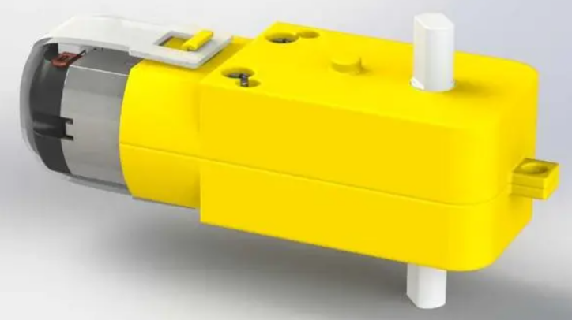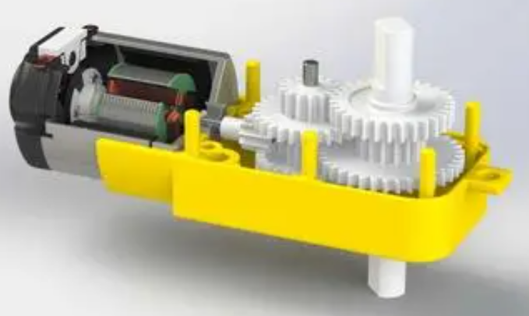

**DC Motor**

When motor is connected to the power supply, it will rotate in one direction. Reverse the polarity of power supply, the motor will rotate in the opposite direction.

And the speed of motor depends on the voltage between two ends. The larger the voltage, the lager the speed.

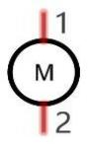

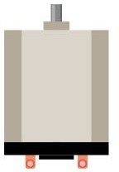

PWM

PWM, Pulse Width Modulation, uses digital pins to send certain frequencies of square waves, that is, the output of high levels and low levels, which alternately last for a while. The total time for each set of high levels and low levels is generally fixed, which is called the period (the reciprocal of the period is frequency). The time of high level outputs are generally called “pulse width”, and the duty cycle is the percentage of the ratio of pulse duration, or pulse width (PW) to the total period (T) of the waveform.

The longer the output of high levels last, the larger the duty cycle and the higher the corresponding voltage in analog signal will be. The following figures show how the analogs signal voltage vary between 0V-5V (high level is 5V) corresponding to the pulse width 0%-100%:

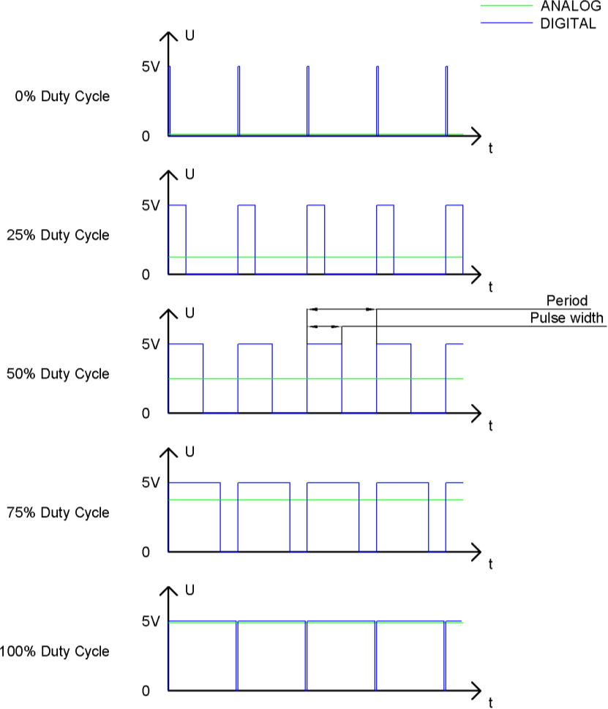

The longer the PWM duty cycle is, the higher the output power will be. Now that we understand this relationship, we can use PWM to control the brightness of an LED or the speed of DC motor and so on.

 GND GND 

## 3.2 Knowledge of L293D Motor control shield

### 3.2.1 Structure

The L293D motor control shield is mainly composed of 2 L293D motor driver chips and a 74HC595 shift register. Its structure is as follows

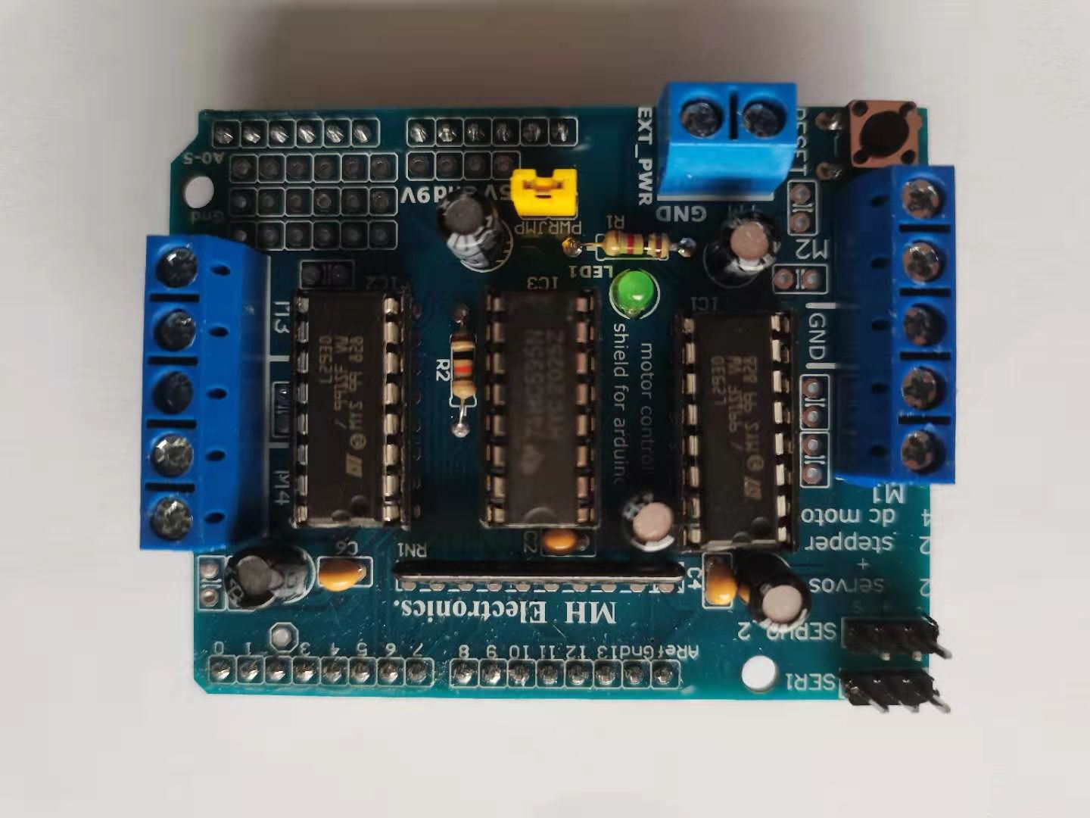

L293D Dirve IC 1#

L293D Dirve IC 2#

74HC595 Shift Register

### 3.2.2 Functions of L293D motor control shield

L293D is a dual-channel H-bridge motor driver that can drive a pair of DC motors or a single stepper motor.

Since the shield has two L293D motor driver chipsets, which means it can drive up to four DC motors individually, it is ideal for building a four-wheeled robotic platform.

The shield provides a total of 4 H-bridges, each of which can supply up to 0.6A to the motor.

The shield also comes with a 74HC595 shift register that extends the 4 digital pins of the UNO board to the 8 direction control pins of the two L293D chips.

The shield has an array of pull-down resistors to keep the motors off during power up.

Onboard LEDs indicate that motor power is OK. If it is not lit, the motor will not run.

The RESET button is the reset button of the UNO board (when the L293D shield is installed on the UNO board).

### 3.2.3 L293D motor control shield principle

Using L293D to drive the motor, there is a 74HC595 chip in the middle that converts serial signals into parallel signals. This module is designed for Arduino, which has fewer I/O ports and requires 12 pins to control 4 DC motors. Using 74HC595 can reduce the use of 4 pins

74HC595

74HC595 is an 8-bit serial input and parallel output displacement buffer: parallel output is a three state output. On the rising edge of SCK, serial data is input from SDL to the internal 8-bit displacement buffer and output from Q7 ', while parallel output stores the data from the 8-bit displacement buffer to the 8-bit parallel output buffer on the rising edge of LCK. When the control signal of the serial data input end OE is low enabled, the output value of the parallel output end is equal to the value stored in the parallel output buffer. Simply put, first set pin 7 of the module to 0, and then pin 4 of the module (clock end for data input of 74HC595 chip) receives a rising edge. Move the 8-bit data in the chip to the left by one bit, leaving the low bit to write the 0 or 1 signal of pin 8 (serial data input of 74HC595 chip) to the low bit. After writing eight times, write the 8-bit signal that controls four motors to the 74HC595 chip (M3M4M3M2M1M2M4), Then, by giving a rising edge to pin 12, the data in the chip is output to the pins of the chip (Q0~Q7)

### 3.2.4 L293D motor control shield schematic diagram

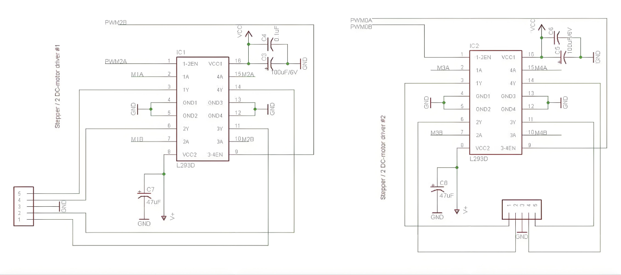

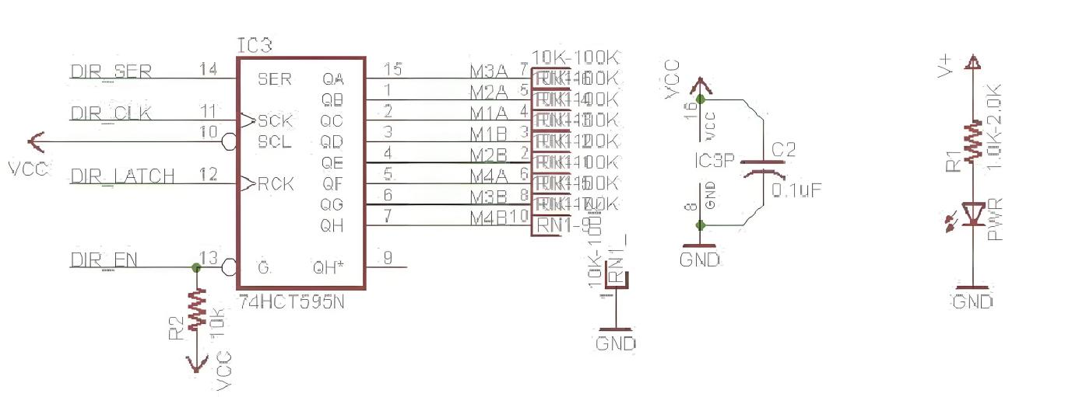

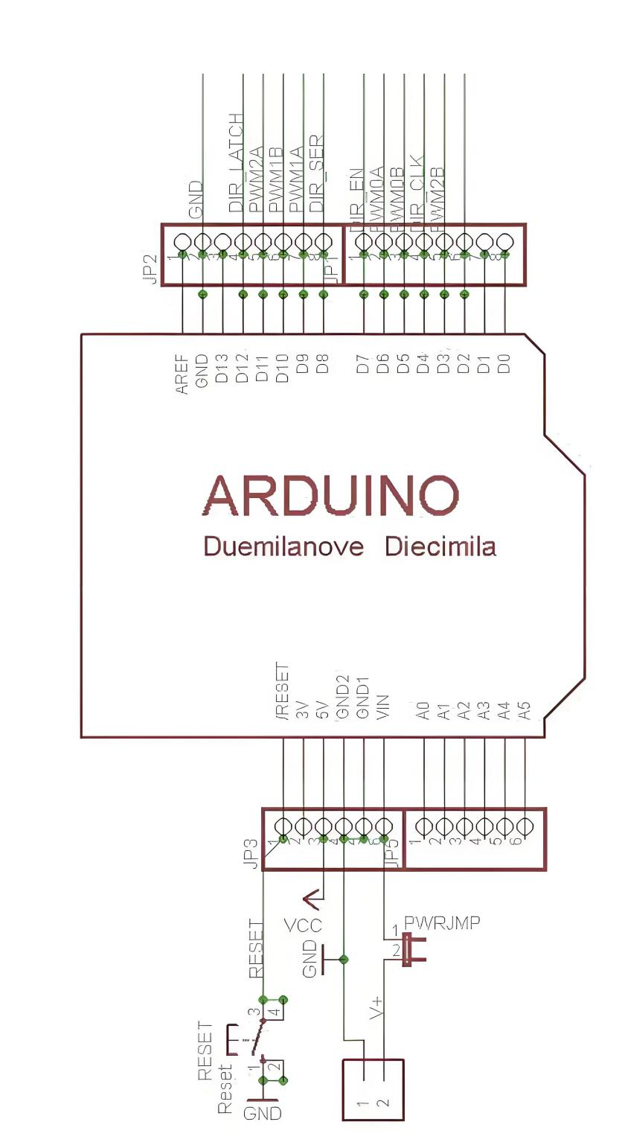

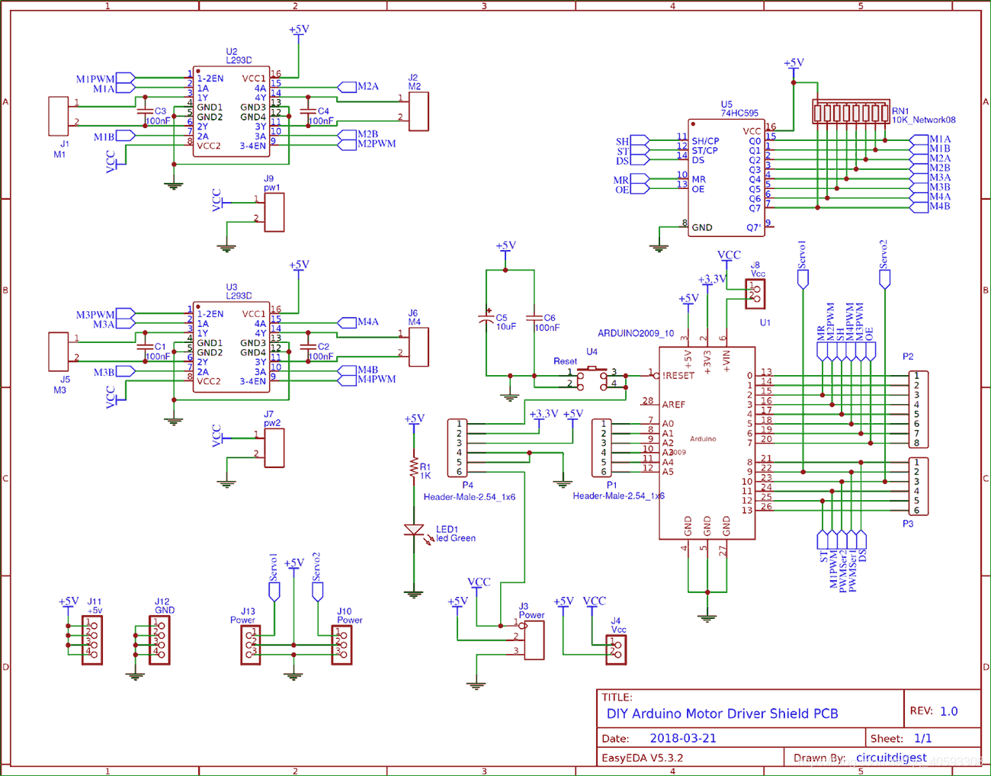

L293D motor control shield occupies Arduino pin corresponding table

|  |  |
| --- | --- |
| L293D motor control shield | Arduino UNOR3(for example) |
| **L293D Driver IC1#1-2EN (M1)** | **D11** |
| **L293D Driver IC1#3-4EN (M2)** | **D3** |
| **L293D Driver IC2#1-2EN (M3)** | **D5** |
| **L293D Driver IC2#3-4EN (M4)** | **D6** |
| **74HC595 DIR-SER** | **D8** |
| **74HC595 DIR-CLK** | **D4** |
| **74HC595 DIR-LATCH** | **D12** |
| **74HC595 DIR-EN** | **D7** |
| **SERVO_1** | **D10** |
| **SERVO_2** | **D9** |
| **N/A** | **D2** |
| **N/A** | **D13** |
| **N/A** | **A0** |
| **N/A** | **A1** |
| **N/A** | **A2** |
| **N/A** | **A3** |
| **N/A** | **A4** |
| **N/A** | **A5** |

### 3.2.5 Power the motors through the control shield

Use a single DC power supply to power both the UNO board and the control shield board, just plug the DC power supply into the DC jack of the UNO board or the 2 pin EXT_PWR on the control shield board.

Please keep the power jumper of the control shield on the board, it can only be used when the working voltage of the motor is less than 9V.

**Note：**

**Do not supply more than 9V at the EXT_PWR input when the jumper is in place, or you may damage the Arduino UNO Board!**

### 3.2.6 Output/input terminal of the L293D motor control shield



Servo 1 Terminals

DC Motot 1#

DC Motot 2#

DC Motot 3#

DC Motot 4#

GND

GND

DC-

DC+

Servo 2 Terminals

PWR JMP

A0-------A5

The output channels of the two L293D chips output M1, M2, M3 and M4 through two 5-pin screw terminals. These terminals support DC motors with operating voltages between 4.5 and 25V.

Each channel on the module can supply up to 600mA to the DC motor. However, the amount of current supplied to the motor depends on the power supply to the system.

You can also connect two stepper motors to the output terminals. One stepper motor is connected to motor ports M1-M2 and the other is connected to M3-M4.

If it is a unipolar stepper motor, connect the center tap of the unipolar stepper motor to the GND terminal.

Two servos can be connected by pulling the 16-bit PWM output lines out to two 3 pin connectors.

### 3.2.7 Unused pins on L293D motor control shield

Mount the shield on the UNO board, it does not occupy the digital pins #2, #13 and analog pins A0-A5 of the UNO board. If you want to use these pins, you can connect some headers to the corresponding places.

# Circuit connection

Assemble the chassis according to Lesson 3, then fix the Arduino UNO R3 board in the development board assembly area of the chassis with 2 M3 * 10mm round head screws, the assembly is completed as shown in the following figure:：

Then insert the L293D motor control shield onto the UNO R3, connect the wire of the left rear wheel TT motor to the M2 interface of the L293D motor contra shield, connect the wire of the right rear wheel TT motor to the M3 interface of the L293D motor contra shield, and insert the MG90S Micro Servo connector into the SERVO2 position of the L293D motor contra shield. Finally, connect the wires of the 18650 battery pack to the power interface (+M GND) of the L293D motor contro shield.

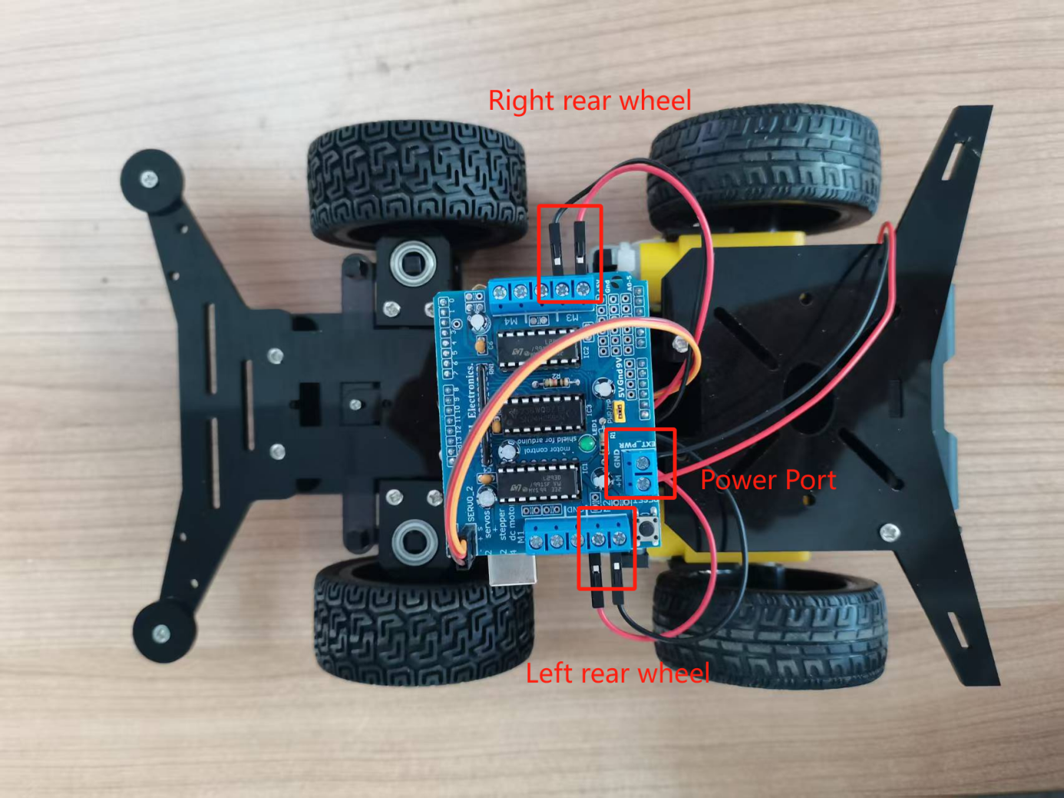

# Upload code and run

Click "File---"Open" in the IDE interface, and select the code under the path of "CKK0020-main\Tutorial\ Arduino\Sketches\ Demo2".

## 5.1 Install AFMotor Library

In order to establish communication with the L293D motor control shield, we need to install the **AFMotor.h** library first so that it can issue commands to control DC, stepper and servo motors.

Click Arduino IDE interface “Sketch”>“Include library”>“ADD .ZIP Library...”

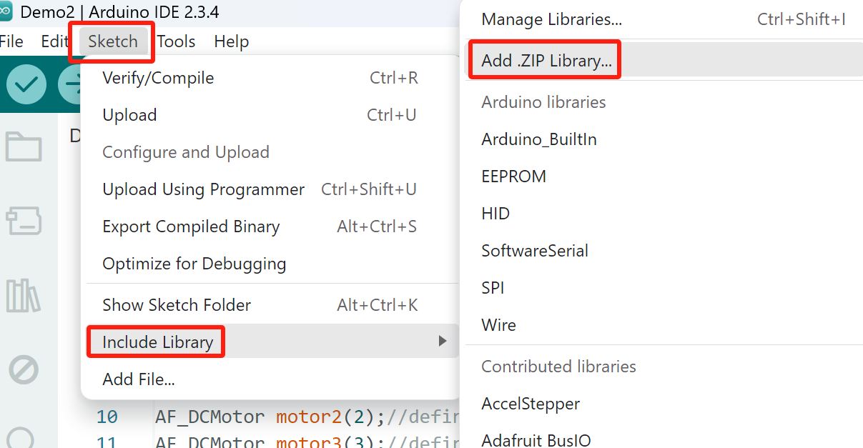

Find the Adafruit_Motor_Shield_library.ZIP file in E:CKK0020-main\Libraries\Adafruit_Motor_Shield_library.zip"

Double click the Adafruit_Motor_Shield_library.ZIP file,then it will be installed into Arduino IDE.

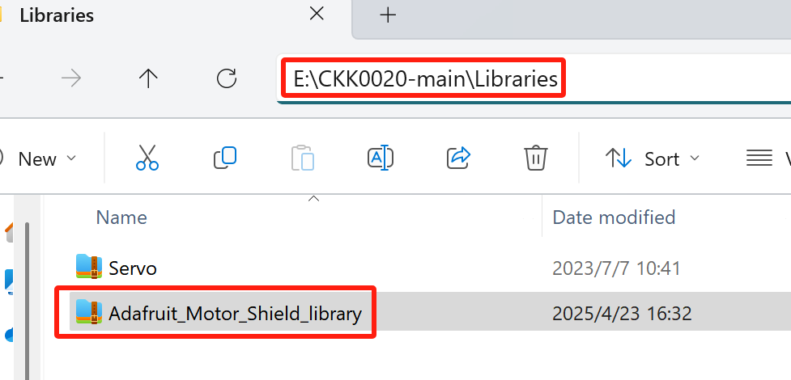

## 5.2 Compile and upload code

After the code is compiled successfully, connect the UNO board on the chaissis body to the computer with a USB cable, and upload the code.

click the  button to compile the code,successfully compiled the code will display “Done compiling”.

Click the "upload"  button on the IDE interface to start uploading the code to the UNO board.

"Done uploading" will be displayed when the program upload is completed.

After the upload is successful, Insert two fully charged 18650 batteries into the battery box.

The car will perform cyclic motion according to the motion logic set by the code. The motion logic set by the code is： forward for 2 seconds----stop for 1 second----backward for 2 seconds----stop for 1 second----move forward right for 0.5 seconds----stop for 1 second----move forward left for 0.5 seconds----stop for 1 second. You can modify the code according to your own needs to enable the car to achieve more complex and varied motion trajectories.

# Make your suggestion and get support

THANK YOU for participating in this learning experience!

If you find errors, omissions or you have suggestions and/or questions about this document, please feel free to contact us: **[cokoino@outlook.com](mailto:cokoino@outlook.com)**

We will make every effort to make changes and correct errors as soon as feasibly possible and publish a revised version.

If you want to learn more about Arduino, Raspberry Pi, Smart Cars, Robotics and other interesting products in science and technology, please continue to visit our Amazon Store by search for "LK COKOINO" on Amazon. Or visit our official website: [www.cokoino.com](http://www.cokoino.com)

We will continue to launch fun, cost-effective, innovative and exciting products.

Thank you again for choosing Cokoino products.

**LK COKOINO**